7/24/2020

**Introduction to Database**

Assignment 3 Part A.

Shankar Sigdel

ID: 301110925

Centennial College

Prof. Vijayalakshmi Tiruchengode Angamuthu

1. List all authors whose last name contains the letter pattern “IN.” Put the results in order of last name, then first name. List each author’s last name and first name.

SELECT fname, lname FROM author WHERE lname LIKE '%IN%' ORDER BY lname, fname;

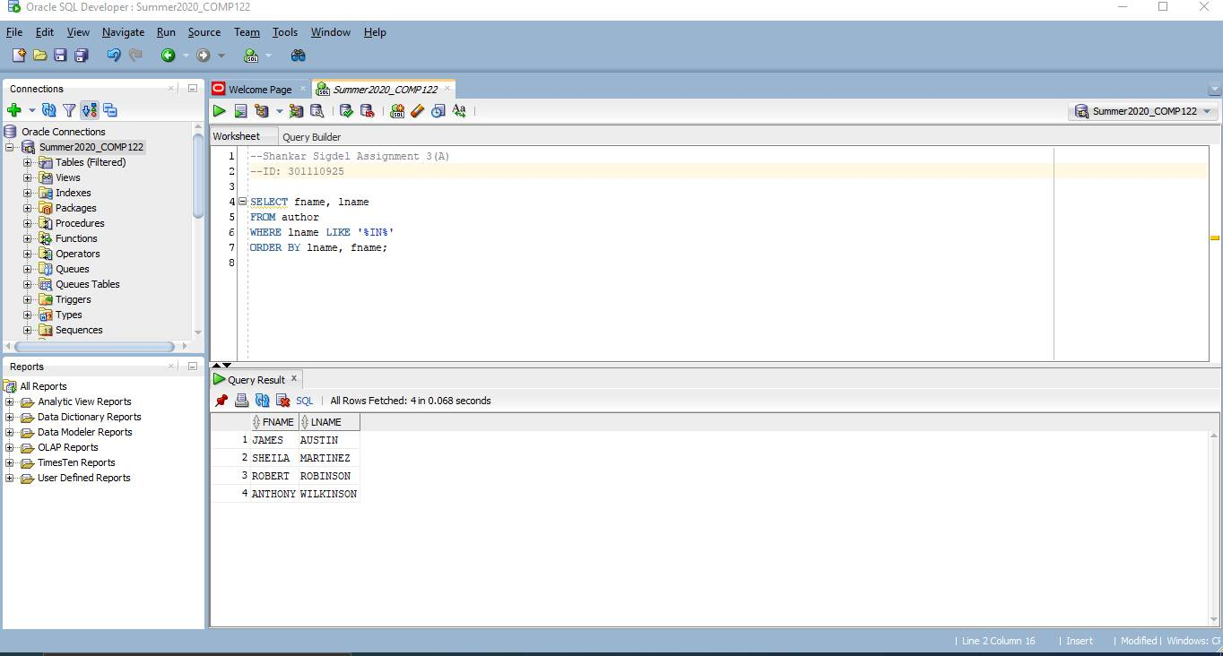

1. List all customers who were referred to the bookstore by another customer. List each customer’s last name and the number of the customer who made the referral.

Select lastname, referred FROM customers WHERE referred IS NOT NULL;

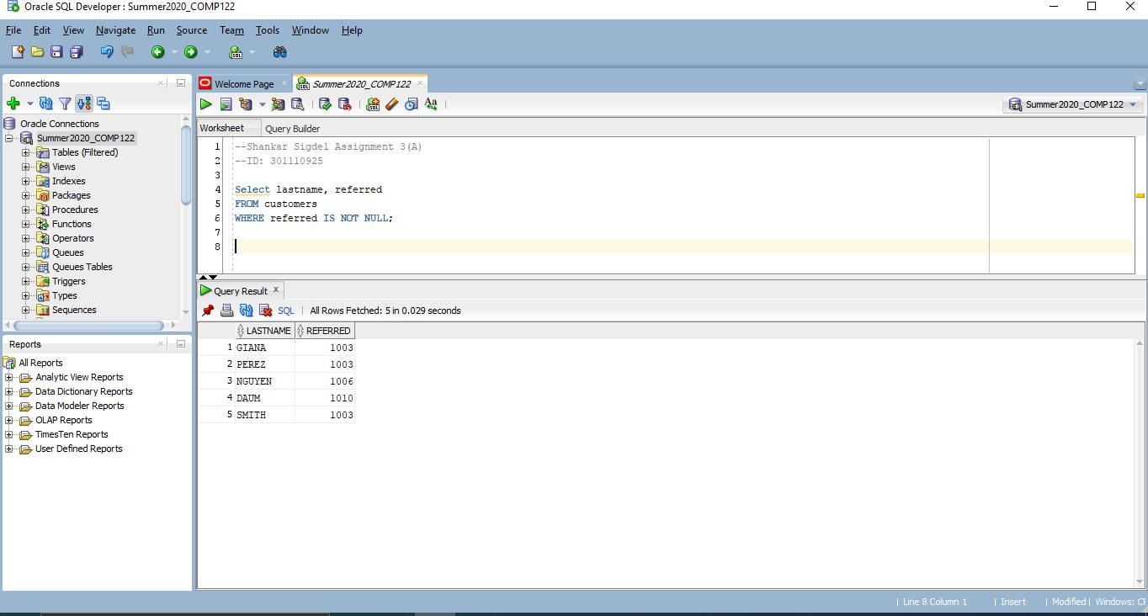

1. Display the book title and category for all books in the Children and Cooking categories. Create three different queries to accomplish this task:
2. a search pattern operation, SELECT title, category FROM books WHERE category LIKE '%C%N%';

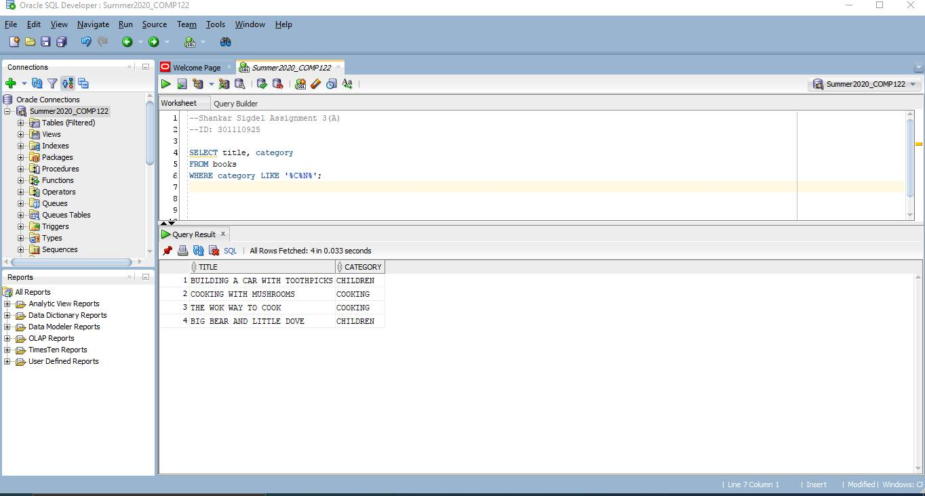

1. a logical operator

SELECT title, category FROM books WHERE category = 'CHILDREN' or category = 'COOKING';

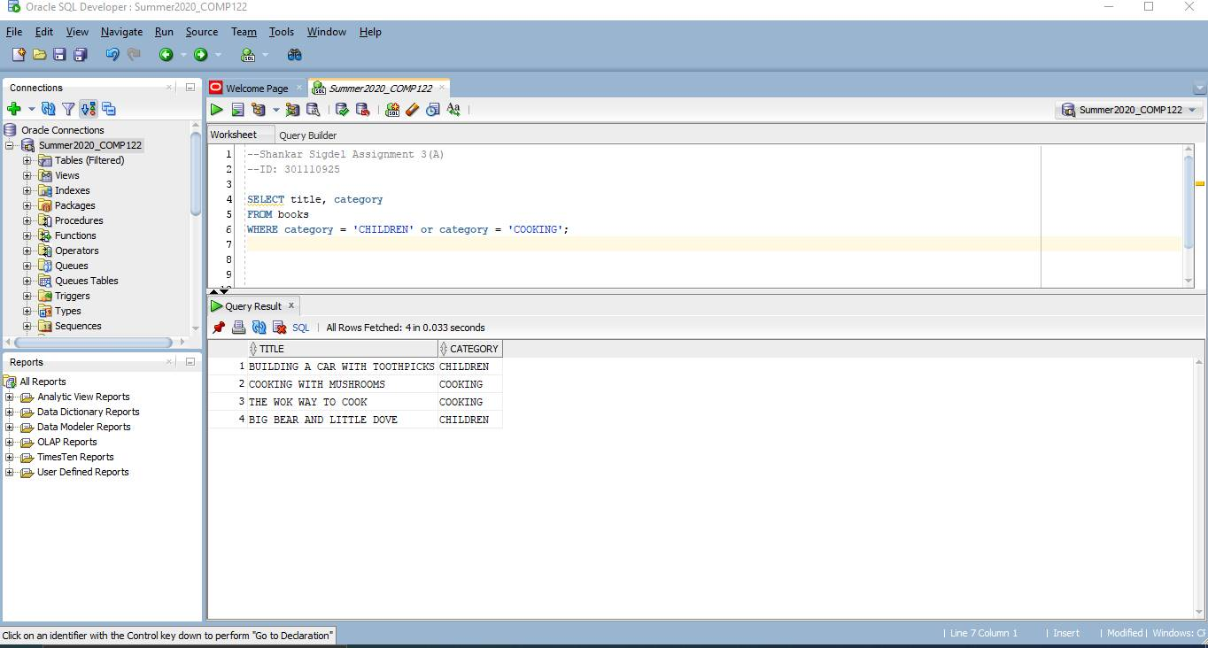

1. another operator not used in a or b.

SELECT title, category FROM books WHERE category IN ('CHILDREN', 'COOKING');

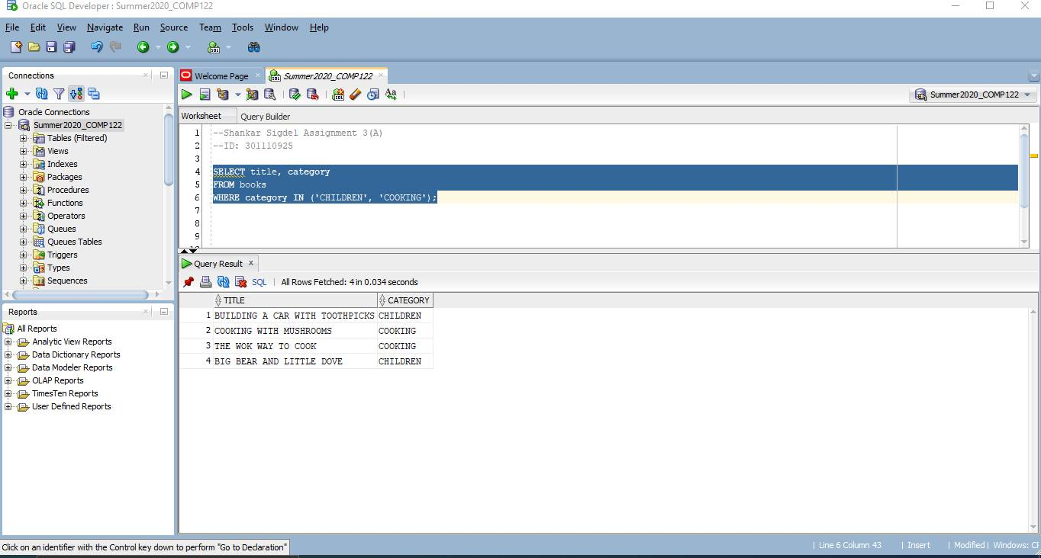

1. . Use a search pattern to find any book title with “A” for the second letter and “N” for the fourth letter. List each book’s ISBN and title. Sort the list by title in descending order.

SELECT isbn, title FROM books WHERE title LIKE '_A_N%' ORDER BY title DESC;

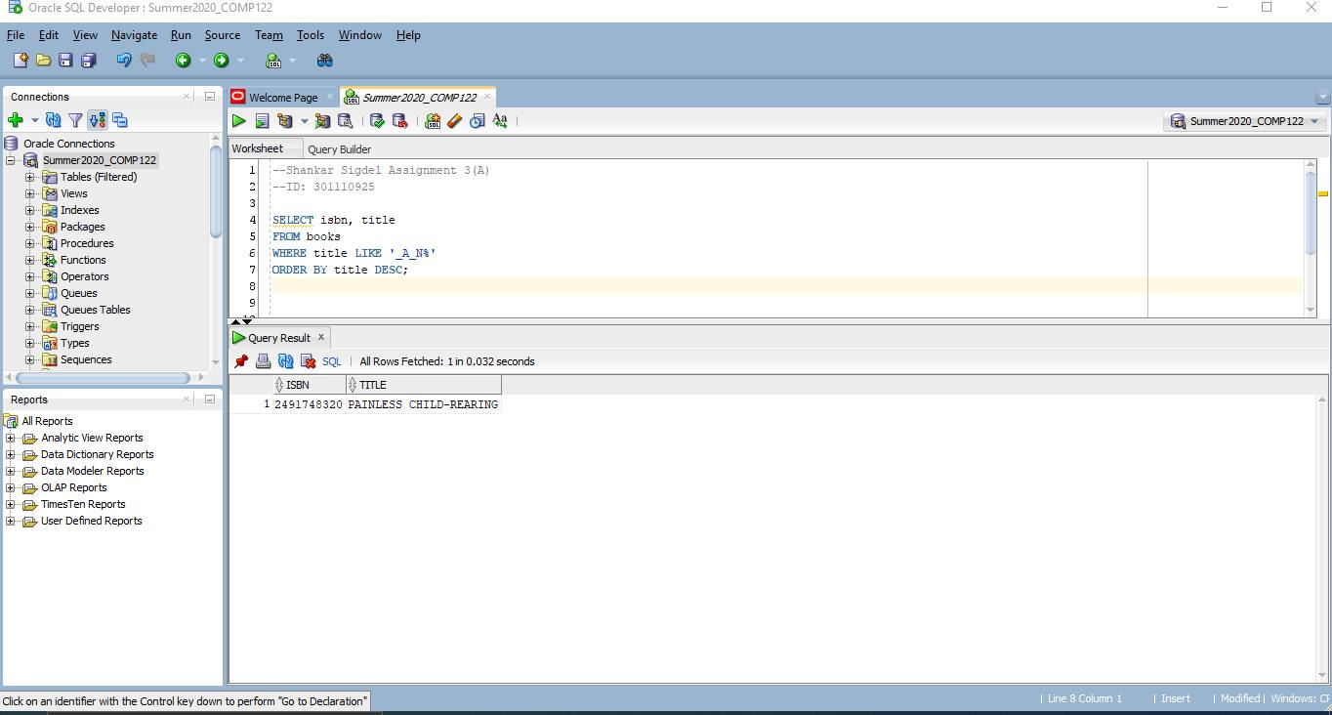

1. List the title and publish date of any computer book published in 2005. Perform the task of searching for the publish date by using three different methods:
2. a range operator,

SELECT title, pubdate FROM books WHERE category = 'COMPUTER' AND pubdate BETWEEN '01-JAN-05' AND '31-DEC-05';

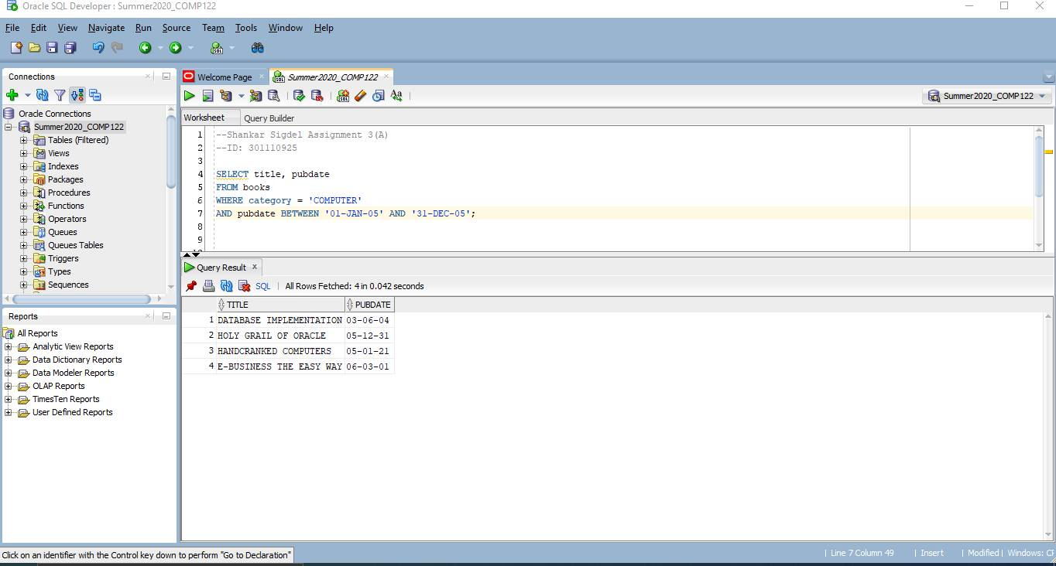

1. a logical operator,

SELECT title, pubdate FROM books WHERE category = 'COMPUTER' AND pubdate>='01-JAN-05' AND pubdate <= '31-DEC-05';

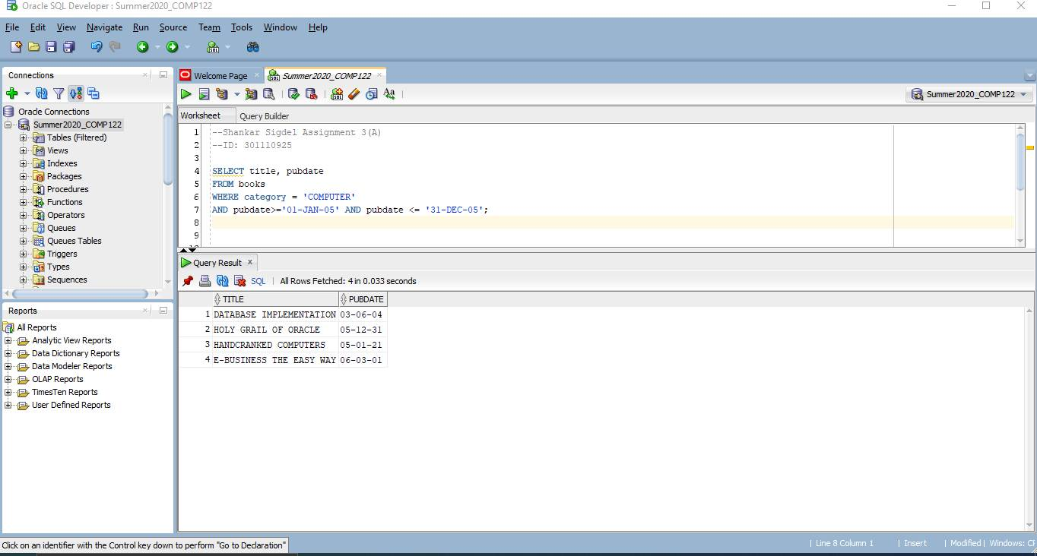

1. a search pattern operation.

SELECT title, pubdate FROM Books WHERE category ='COMPUTER' and pubdate LIKE '%05';

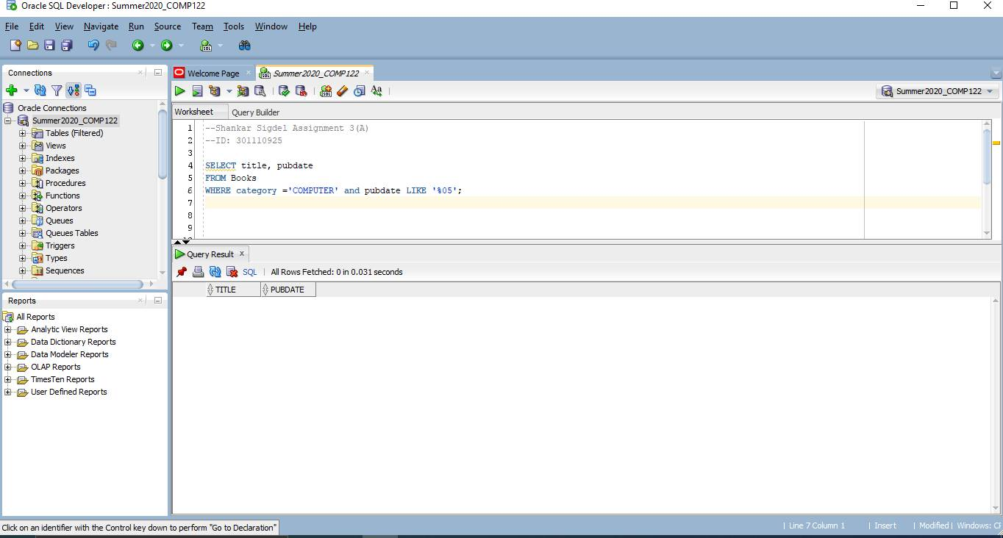

1. A customer service representative is trying to identify all books in the Computer or Family Life category and published by Publisher 1 or Publisher 3. However, the results shouldn’t include any book selling for less than $45.00

SELECT isbn, title, category, pubid, retail FROM books WHERE category='COMPUTER' OR category= 'FAMILY' AND pubid IN '1,3' AND retail >= 45;

